Directions for making Elective Course Selections for 2022-2023

- Log in using your FCS credentials

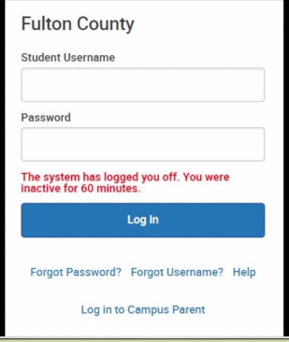

- Select Academic Plan from the menu
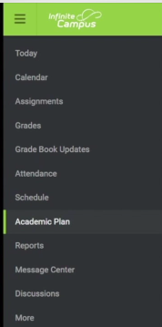
- Select the “Next” button in order to proceed to see the Academic Plan. Completing these boxes is not necessary.
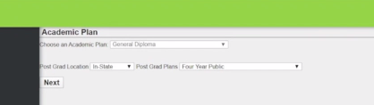

- When the plan populates you should see 9th, 10th, 11th and 12th grade years. Teachers have made recommendations for the next school year which cannot be changed at this phase. You are only making choices for the next school year. Every student must have a total of 6.0 credits.

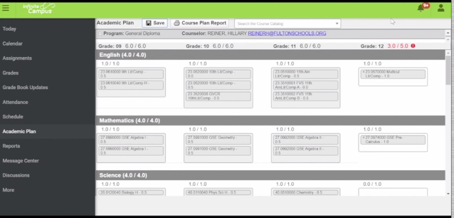

- To find electives click the “search” bar at the top of the page. Enter the name of the course you wish to take.

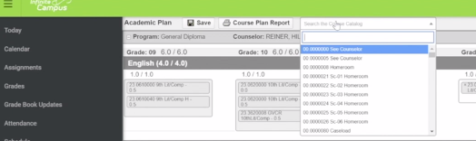

- The course will populate in a box and at the bottom of the box will be a tab stating “Add to Grade”. Click the add to Grade button that applies to the grade you will be in next year.
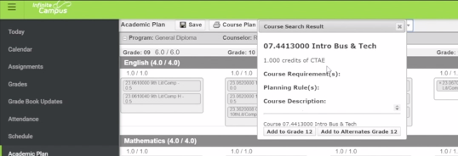

- That course will now populate in the appropriate place in the academic plan. If this course is not offered or requires special permission, you will have to wait until the next phase to request the course. Please, remember that we will no longer be using yearlong course numbers so you may have to add two semester number (01/02) courses to complete the box. Enter both semester course numbers to your plan.
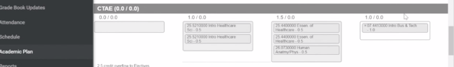

- After you have made all of your choices leaving 6.0 credits requested, you must select “SAVE” to successfully save your selections.
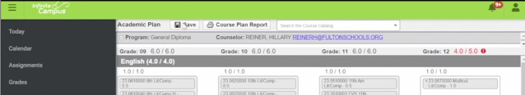

- After you select “SAVE” a box will pop up. Please ignore all the information in this box and click
“OK”. The information in this box is irrelevant to this process.
